MAR. 5 (kickoff) – Vote to help your city win a new all-abilities playground
Facebook | 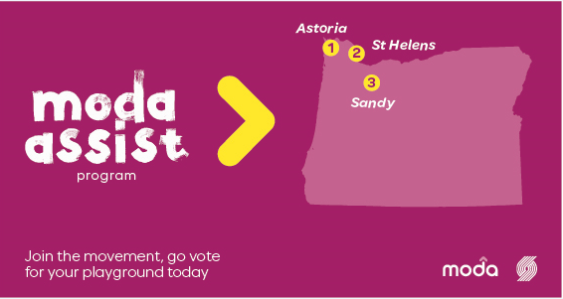  Voting for the Moda Assist Program starts today! Help <YOUR CITY> win funds for new all-abilities playground equipment. Just go to www.nba.com/blazers/assists and vote! The city with the most votes on April 1 wins. @ModaHealth @trailblazers
Twitter | Vote today to help <YOUR CITY> win new all-abilities playground equipment: www.nba.com/blazers/assists @Moda_Health @trailblazers
MARCH 13 – One week left to vote for your city
Facebook | 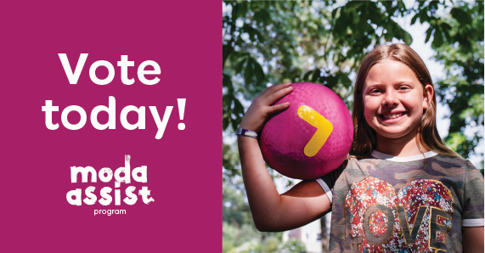  Just one week left to vote for <YOUR CITY> to win funds for new all-abilities playground equipment. Go to www.nba.com/blazers/assists and vote today! Voting ends Monday, March 20. @ModaHealth @trailblazers
Twitter | One week left to vote for <YOUR CITY>: www.nba.com/blazers/assists @Moda_Health @trailblazers
MARCH 17 – 3 days left to vote for your city
Facebook | 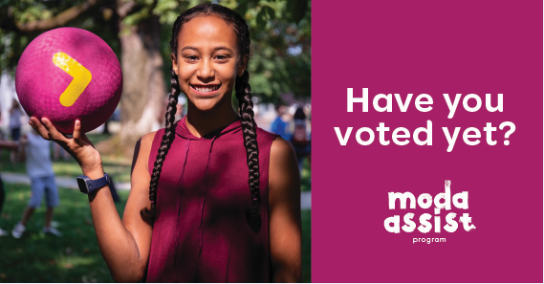  Only 3 days left to vote for <YOUR CITY>! Make it count. Go to www.nba.com/blazers/assists your vote to win new all-abilities playground equipment. @ModaHealth @trailblazers
Twitter | 3 days left to vote for <YOUR CITY>! Go to www.nba.com/blazers/assists and vote. @Moda_Health @trailblazers
MARCH 20 – Last day to vote for your city
Facebook | 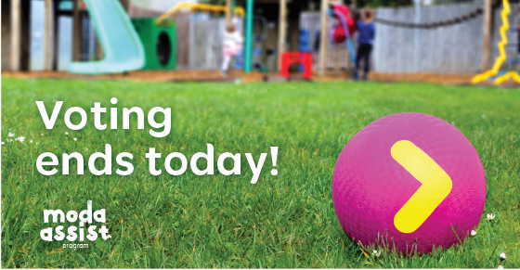  Today’s the last day to vote for <YOUR CITY> to win the Moda Assist Program funds for new all-abilities playground equipment. Vote now at www.nba.com/blazers/assists! @ModaHealth @trailblazers
Twitter | Last day to vote for <YOUR CITY> to win the Moda Assist Program all-abilities playground equipment! Vote now: www.nba.com/blazers/assists @Moda_Health @trailblazers

